**HTML Assignment 1**

Q.1

<!DOCTYPE html>

<html>

<head>

    <title>Question 1</title>

</head>

<body style="background-color:yellow;">

    <h1 style="background-color: red;">This is a Heading</h1>

    <h2>

        <p style="background-color: green;">This is a paragraph.</p>

    </h2>

    </style>

</body>

</html>

Output:

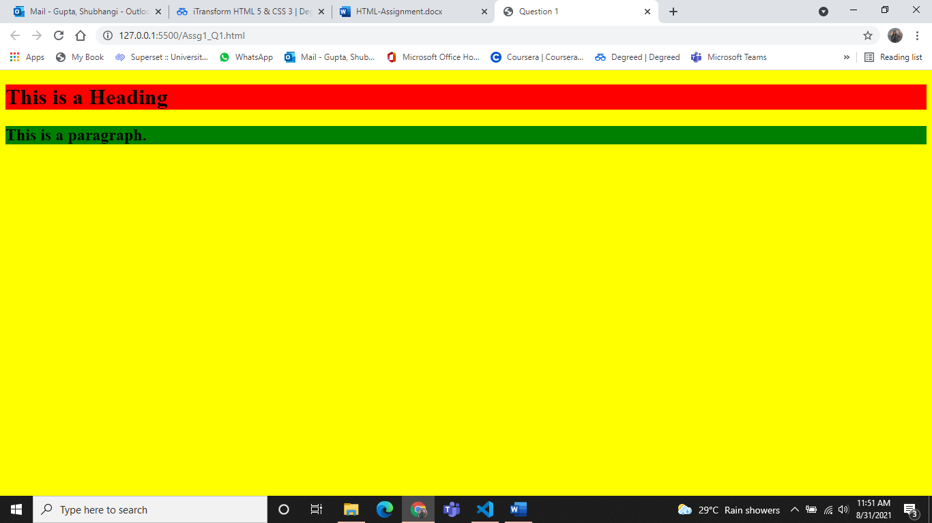

Q.2

<!DOCTYPE html>

<html>

<head>

    <title>Question 2</title>

</head>

<body>

    <h2>Create a link of an image:</h2>

    <img src=https://cdn.shopify.com/s/files/1/1061/1924/products/Smiling_Emoji_with_Smiling_Eyes_large.png?v=1571606035 width="100" height="100" border="2">

    <h2>No border around the image, but still a link:</h2>

    <img src=https://cdn.shopify.com/s/files/1/1061/1924/products/Smiling_Emoji_with_Smiling_Eyes_large.png?v=1571606035 width="100" height="100">

</body>

</html>

Output:

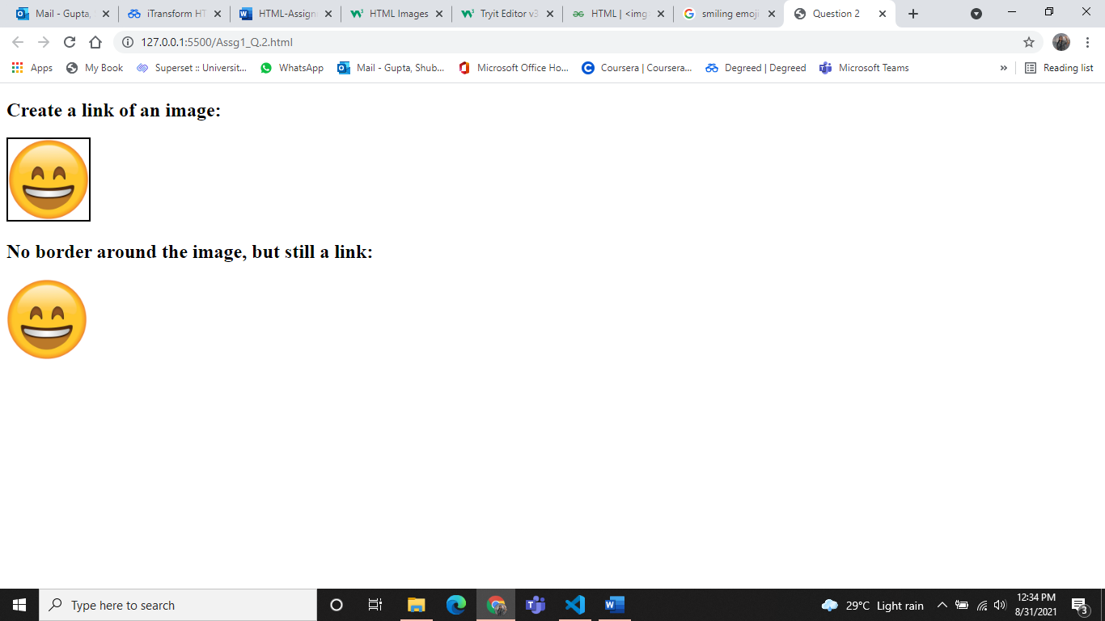

Q.3

<!DOCTYPE html>

<html>

<head>

    <title>Question 3</title>

</head>

<body>

    <p>Each table starts with a table tag. Each table row starts with a tr tag. Each table data starts with a td tag.</p>

    <table border="2">

        <h3>One column:</h3>

        <tr>

            <td>100</td>

        </tr>

    </table>

    <table border="2">

        <h3>One row and three Columns:</h3>

        <tr>

            <td>100</td>

            <td>200</td>

            <td>300</td>

        </tr>

    </table>

    <table border="2">

        <h3>Two rows and three Columns:</h3>

        <tr>

            <td>100</td>

            <td>200</td>

            <td>300</td>

        </tr>

        <tr>

            <td>400</td>

            <td>500</td>

            <td>600</td>

        </tr>

    </table>

</body>

</html>

Output:

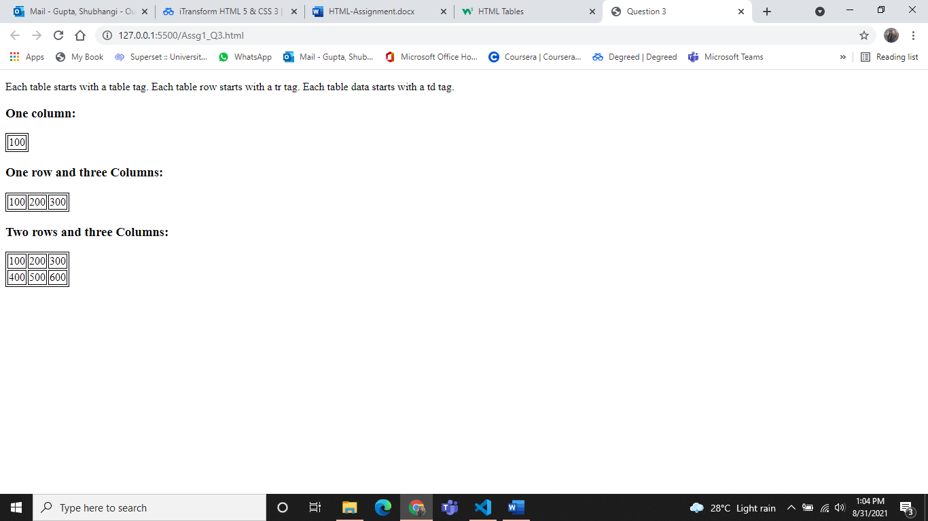

Q.4

<!DOCTYPE html>

<html>

<head>

    <title>Question 4</title>

</head>

<body>

    <table border="2">

        <h3>This table has borders:</h3>

        <tr>

            <td>100</td>

            <td>200</td>

            <td>300</td>

        </tr>

        <tr>

            <td>400</td>

            <td>500</td>

            <td>600</td>

        </tr>

    </table>

    <table>

        <h3>This table has no borders:</h3>

        <tr>

            <td>100</td>

            <td>200</td>

            <td>300</td>

        </tr>

        <tr>

            <td>400</td>

            <td>500</td>

            <td>600</td>

        </tr>

    </table>

</body>

</html>

Output:

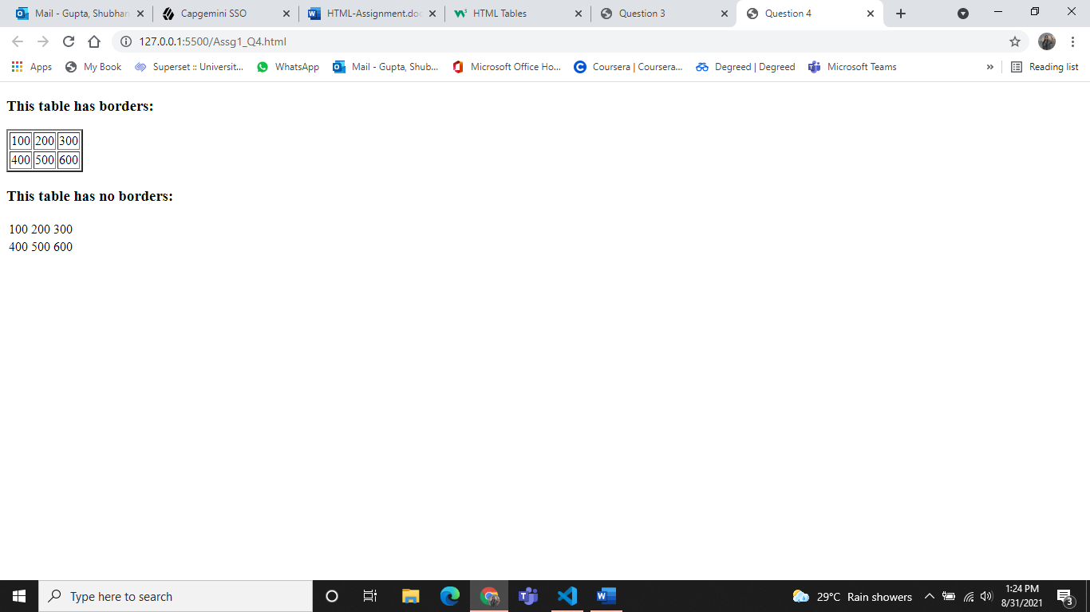

Q.5

<!DOCTYPE html>

<html>

<head>

    <title>Question 5</title>

</head>

<body>

    <h4>Numbered list:</h4>

    <ol>

        <li>Apples</li>

        <li>Bananas</li>

        <li>Lemons</li>

        <li>Oranges</li>

    </ol>

    <h4>Letters list:</h4>

    <ol type="A">

        <li>Apples</li>

        <li>Bananas</li>

        <li>Lemons</li>

        <li>Oranges</li>

    </ol>

    <h4>Lowercase Letters list:</h4>

    <ol type="a">

        <li>Apples</li>

        <li>Bananas</li>

        <li>Lemons</li>

        <li>Oranges</li>

    </ol>

    <h4>Roman numbers list:</h4>

    <ol type="I">

        <li>Apples</li>

        <li>Bananas</li>

        <li>Lemons</li>

        <li>Oranges</li>

    </ol>

    <h4>Lowercase Roman numbers list:</h4>

    <ol type="i">

        <li>Apples</li>

        <li>Bananas</li>

        <li>Lemons</li>

        <li>Oranges</li>

    </ol>

</body>

</html>

Output:

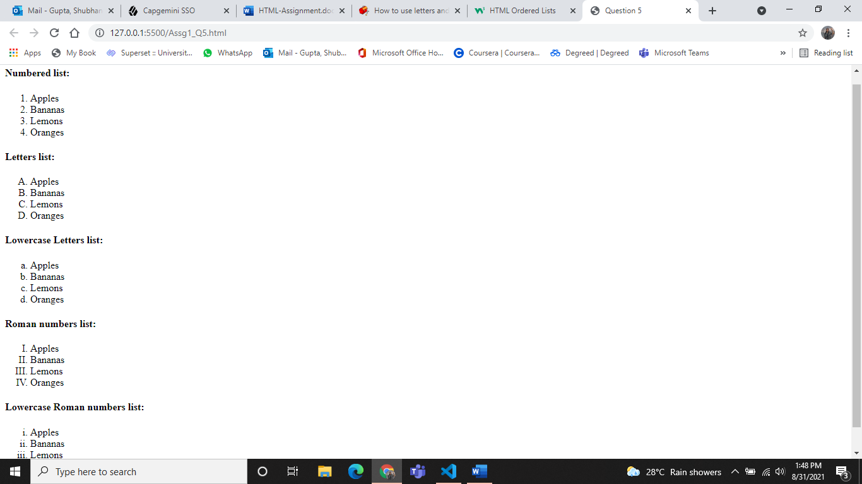

Q.6

<!DOCTYPE html>

<html>

<head>

    <title>Question 5</title>

</head>

<body>

    <form>

        <label for="username">Username:</label><br>

        <input type="text" id="username" name="username"><br>

        <label for="pwd">Password:</label><br>

        <input type="password" id="pwd" name="pwd"><br><br>

        <input type="submit" value="Submit">

    </form>

</body>

</html>

Output:

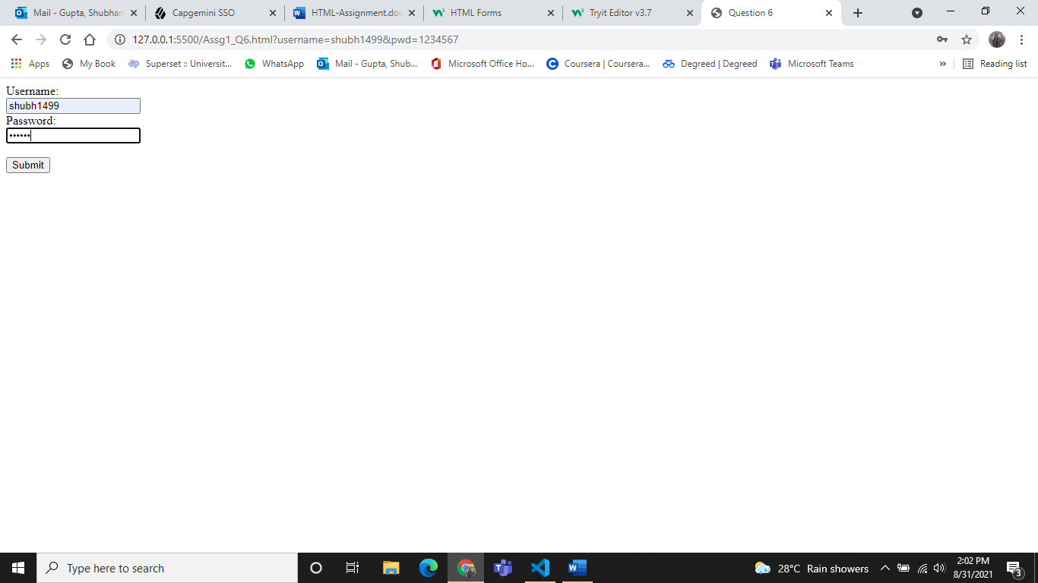

Q.7

<!DOCTYPE html>

<html>

<head>

    <title>Question 7</title>

</head>

<body>

    <form>

        <input type="checkbox" id="vehicle1" name="vehicle1" value="Bike">

        <label for="vehicle1"> I have a bike</label><br>

        <input type="checkbox" id="vehicle2" name="vehicle2" value="Car">

        <label for="vehicle2"> I have a car</label><br>

        <input type="submit" value="Submit">

    </form>

</body>

</html>

Output:

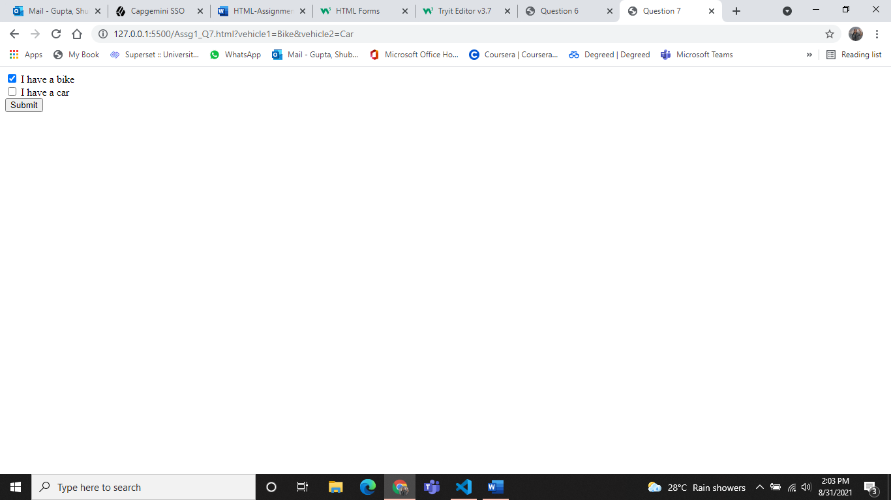

Q.8

<!DOCTYPE html>

<html>

<head>

    <title>Question 8</title>

</head>

<frameset rows="10%,*">

    <frame src="top.html" name="f1" marginwidth="10" marginheight="10"

 frameborder="1">

<frameset cols="10%,*">

            <frame src="left.html" name="f2" marginwidth="10" marginheight="10"

 frameborder="1">

             <frame src="right.html" name="f3" marginwidth="10" marginheight="10" frameborder="1">

                </frame>

        </frameset>

</html>

Top.html Right.html

<!DOCTYPE html> <!DOCTYPE html>

<html> <html>

<head> <head>

    <title>top</title> <title>right</title>

</head> </head>

<body> <body>

    <h1>Top</h1> <h1>Right</h1>

</body> </body>

</html> </html>

Left.html

<!DOCTYPE html>

<html>

<head>

    <title>left</title>

</head>

<body>

    <h1>Left</h1>

</body>

</html>

Output:

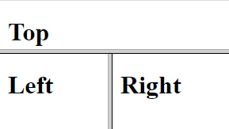

Q.9

<!DOCTYPE html>

<html>

<head>

    <title>Question 9</title>

</head>

<frameset rows="50%,*">

    <frameset cols="50%,*">

        <frame src="tl.html" name="f1" marginwidth="10" marginheight="10"

frameborder="1">

            <frame src="tr.html" name="f2" marginwidth="10" marginheight="10"

frameborder="1">

    </frameset>

    <frameset cols="50%,*">

        <frame src="bl.html" name="f3" marginwidth="10" marginheight="10"

frameborder="1">

            <frame src="br.html" name="f4" marginwidth="10" marginheight="10"

 frameborder="1">

    </frameset>

</frameset>

</html>

tl.html

<!DOCTYPE html>

<html>

<head>

    <title>left</title>

</head>

<body>

    <h1>Top Left</h1>

</body>

</html>

tr.html

<!DOCTYPE html>

<html>

<head>

    <title>right</title>

</head>

<body>

    <h1>Top Right</h1>

</body>

</html>

bl.html

<!DOCTYPE html>

<html>

<head>

    <title>left</title>

</head>

<body>

    <h1>Bottom Left</h1>

</body>

</html>

br.html

<!DOCTYPE html>

<html>

<head>

    <title>top</title>

</head>

<body>

    <h1>Bottom Right</h1>

</body>

</html>

Output:

